IT3122 Cloud Application Development Project (25%)

Name: MOHAMED KHAIRIN BIN RAMLEE
Admin No: 224149Q
Module Group: Group 1
Credentials to your AWS account:
Account ID: 312171776467
User: Default User
In this project, you will be developing a lost-and-found website for NYP using AWS Cloud Services.
This website will display all items that have been returned to the lost-and-found department.

Part 1 – Setup and host a lost-and-found website (7%)

Create a website that allows visitors to the site to display all items that have been returned to the lost-and-found department. You should design your website to be user-friendly and easy to navigate.

- Screenshot your website – listing the various pages that you created
HomePage.jsx:
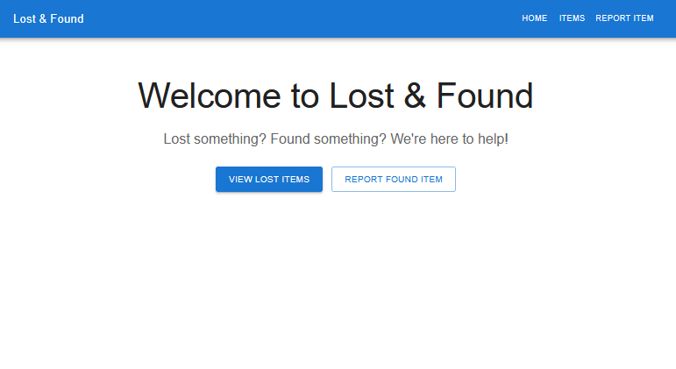
ViewLostItems:
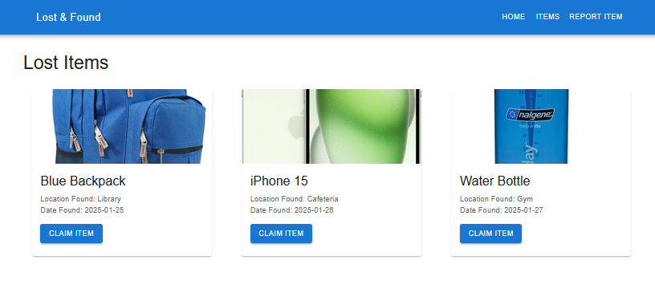
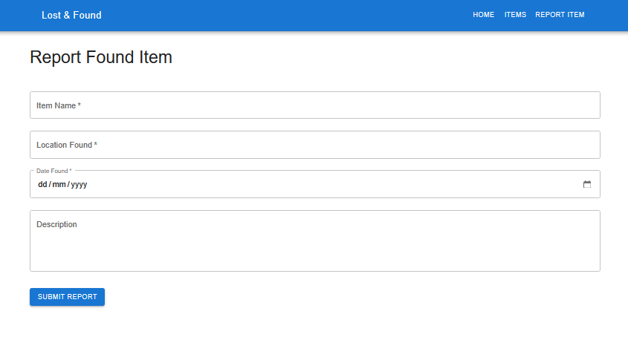
ReportItem:

- Zip up all the source code for website (label Part 1)

Part 2 – Upload lost items to list on website (5%)

When users find new lost items, they bring them to the lost-and-found counter and these new found items will be added to the website.

As more and more items are found, the lost-and-found department decided to design and streamline the process.
New items can be added to the site, by uploading images of the found items with the appropriate descriptions. A database is now needed to maintain and categorize these items for easy searching and listing.
Design and develop your improved website.

- Screenshot your website – listing the various pages that you created and showing all the features of the improved website

ReportItem: (Now has an Upload Image button which is required before submitting report)

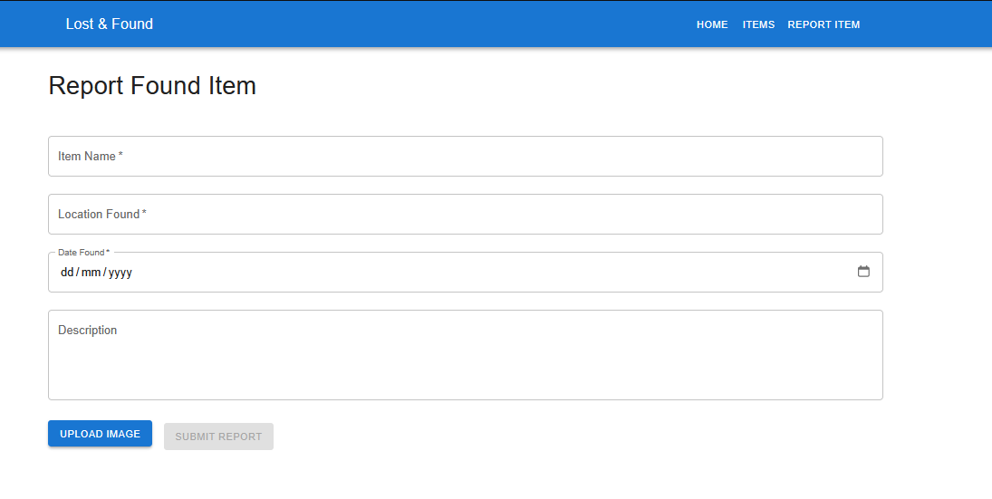

Items: (Slight changes are, shown description, data is retrieved from Prostgress Database)
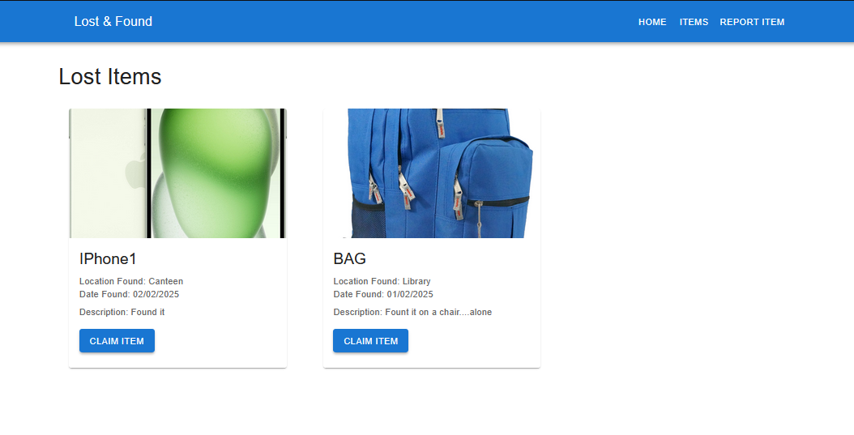

- Screenshot of the database design (you may use SQL or NoSQL)

Using PostgreSQL in AWS RDS:

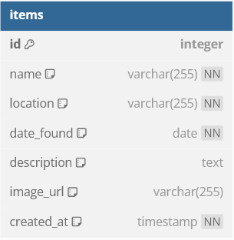

- Write a brief explanation on the choice of database used and the design.

I chose PostgreSQL for my database over other alternatives like Aurora MySQL, Aurora PostgreSQL and MySQL as the normal PostgreSQL provides a bit better and easier management. The other types of databases have advanced features like auto-scaling and read replicas which I would not particularly need for this project, as of right now. PostgreSQL's superior ACID compliance and rich data type support also make it ideal for the scope of the project as of right now. Plus, I haven't tried using PostgreSQL before and would like to have a go at it.

The database design is quite normal and standard as should I say:

ID (auto-incrementing primary key)
- Name of the found item
- Location where it was found
- Date when found
- Description
- Image URL (storing S3 links)
- Creation timestamp

This database structure supports the core functionality of recording and displaying
items, with all data properly organized and easily accessible.

- Zip up all the source code for website and database (label Part 2)
Part 3 (8%)
As the site grew, more and more items were found and claimed and traffic to the site also increased by a lot. The team decided to make it easier for users to find their lost items.
Users can create notification whenever new items are listed on the site or when an item that matched the category of item is uploaded to the site.
The team was also exploring other features to improve user experience and automation (eg using AI to recognize items etc). The team also decided to improve the site by improving availability and reliability.

Design and utilize any AWS service to achieve this feature.
- Screenshot the coding of your improvements and the respective settings. Show evidence that these features are working.
New Items outlook:
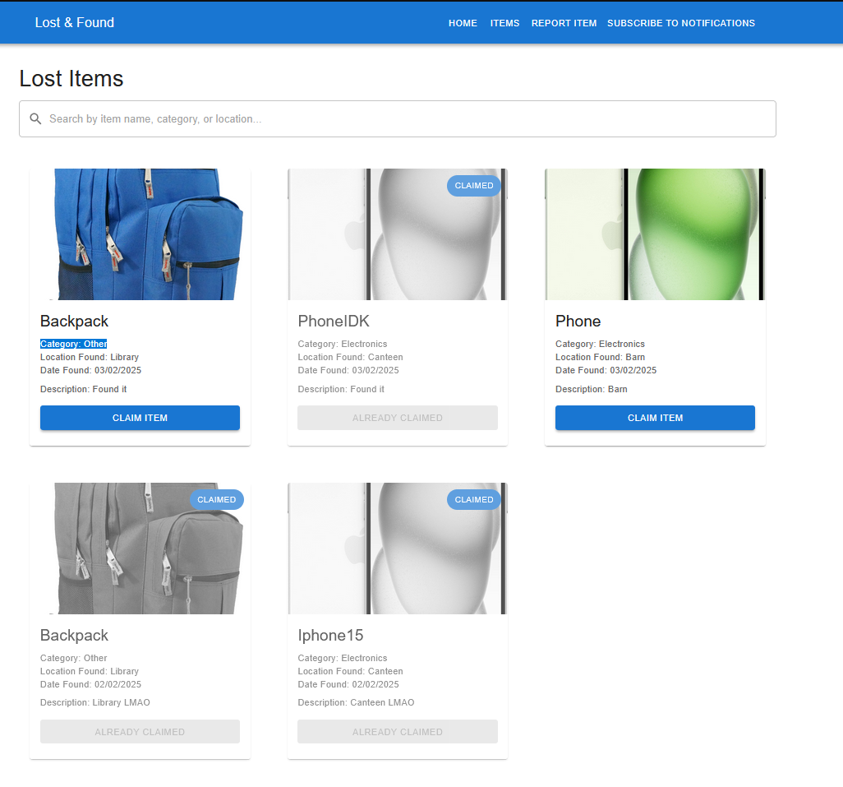
New Upload page:
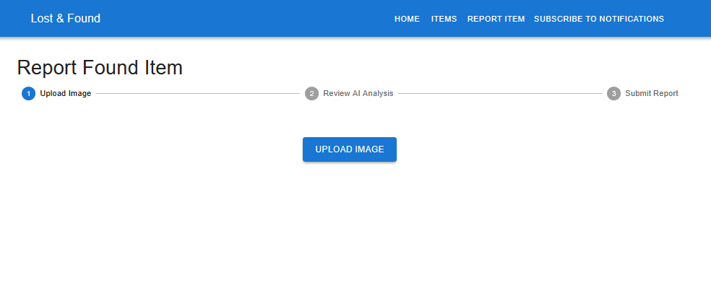

With AI recognition:
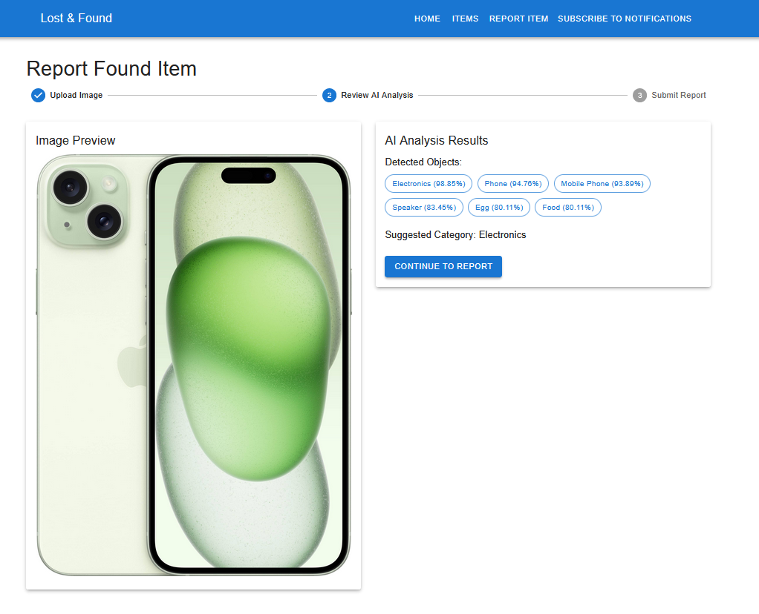

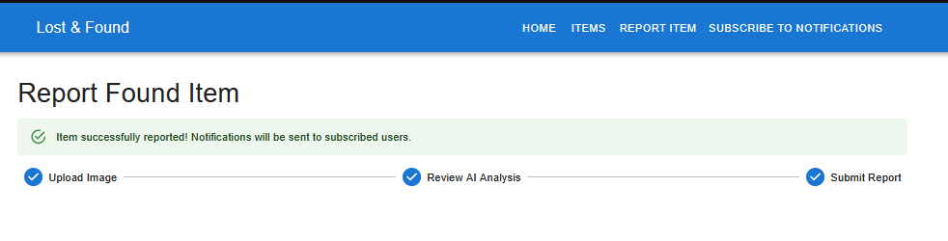

Confirm Claim:
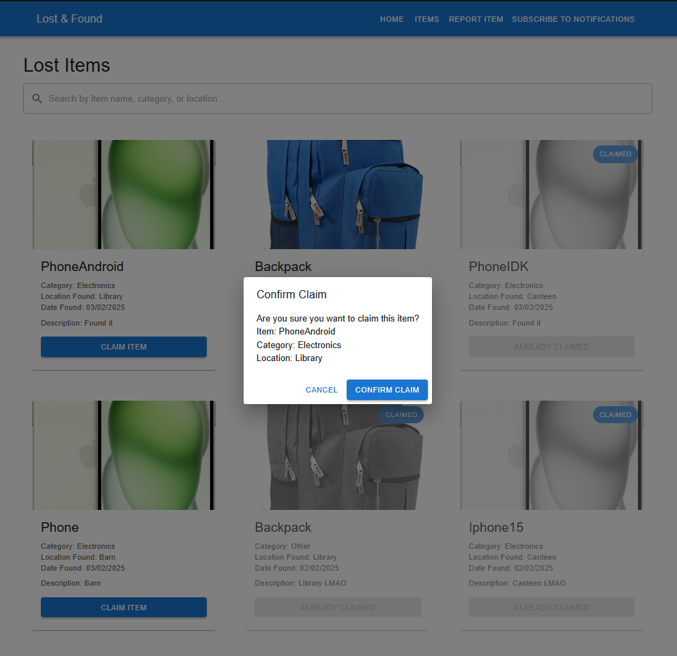

Subscribe to notifications:
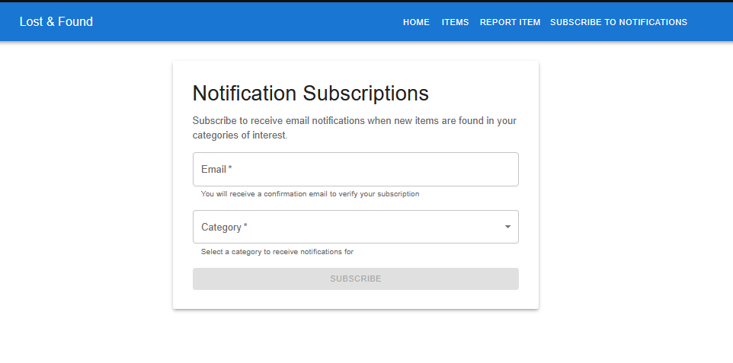

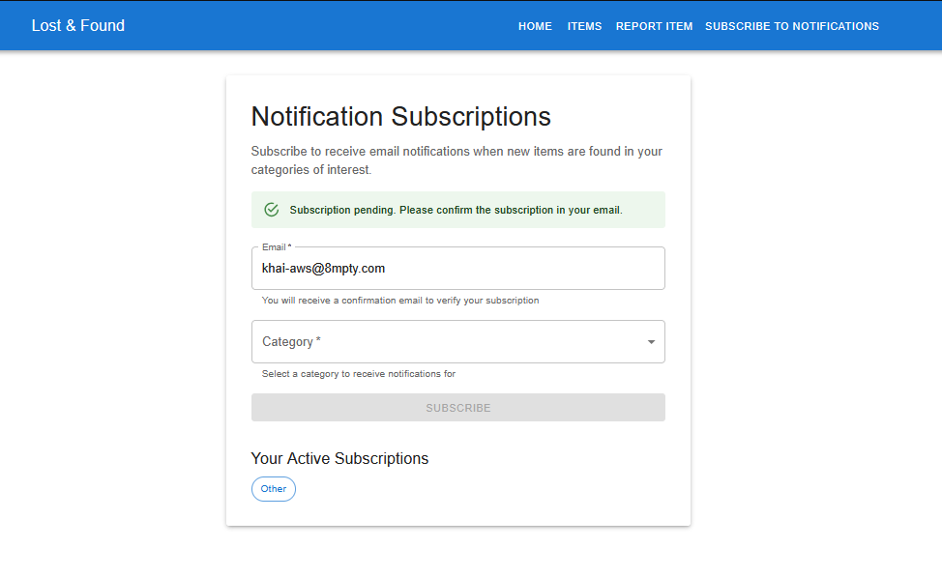

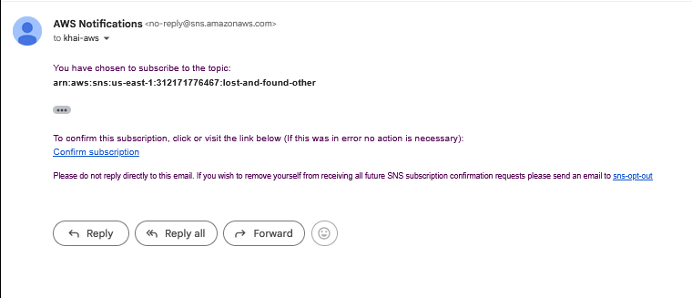
Email Notification:
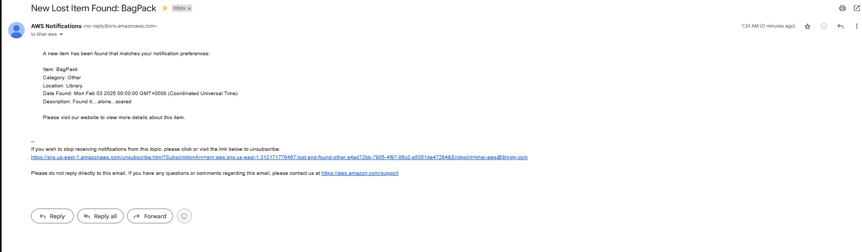

Used S3 to host frontend:
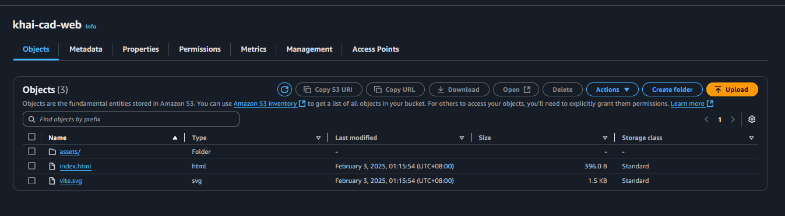
EC2 for Backend:
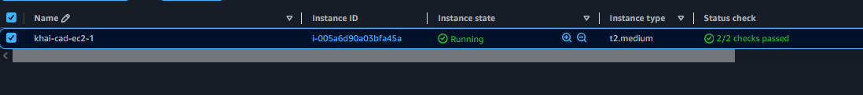

- Document your design and steps with the necessary descriptions and screenshots.
So for my project, I have a backend and frontend. The backend is based on NodeJs while the frontend is based on ReactJS. I decided to then host my application onto the cloud so that way more users around the world could access my web application.
My codes are on Github so that I could clone my project into an EC2 instance that would hold and deploy the application. I used the EC2 only for the backend while the fronted is just the “build” files from ReactJS using “npm run build” and uploaded to a S3 with public access enabled.
The backend, like I said, is hosted on EC2. It is also built and deployed using docker so that it automatically starts the container and backend when the instance ever restarts. I have also used an AI functionality called Amazon Rekognition which would analyze the Uploaded image and “predicts/recommends” what category the item would belong to. Users are now also able to subscribe to a SNS topic which would send them an email notification whenever the desired category has a new item.
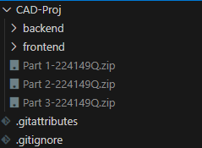
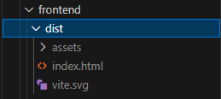
Minor updates to the UI and hosted to S3 and EC2:
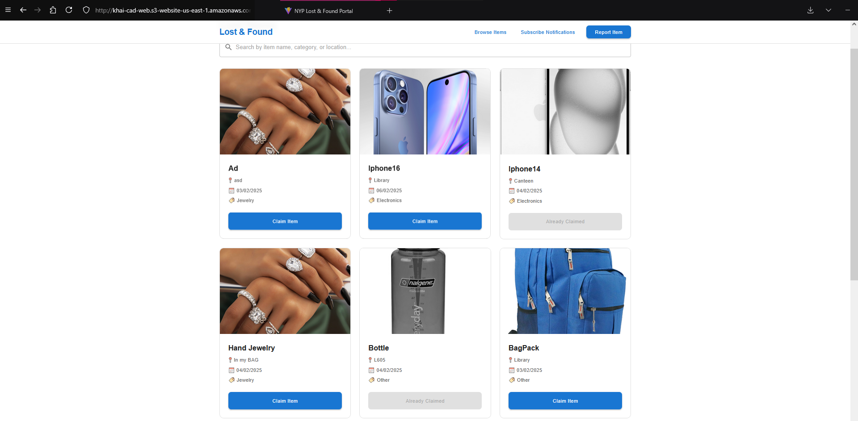
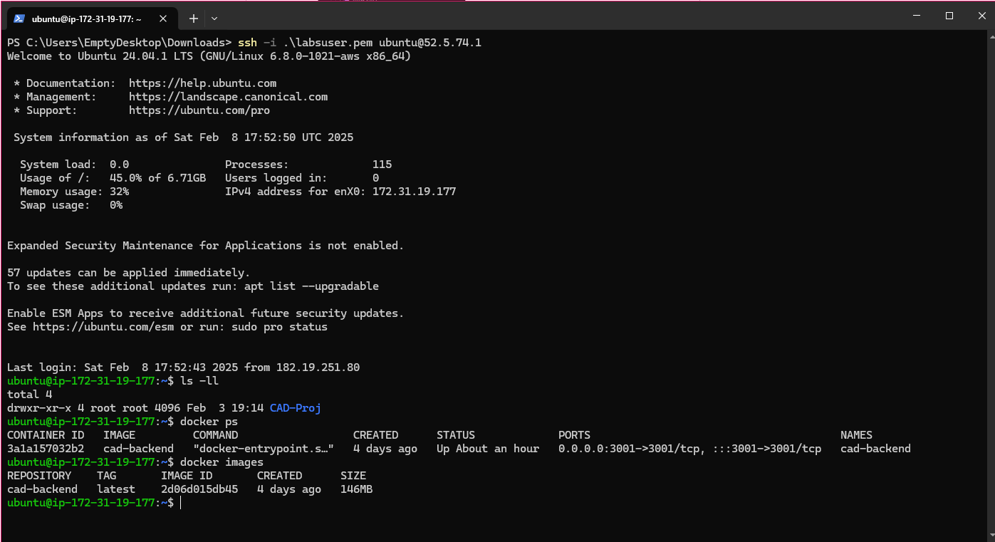

Part 4 (5%) – Advanced automation and features

The lost-and-found project was a great success. Other polytechnics heard about this project and have approached your team for assistance in implementing a similar project.

Design, document and implement your automation plan.

Your team had other plans and ideas for enhancement and improvement to the site, these enhancements should be included

- Document your design and steps with the necessary descriptions and screenshots for the automation process.

I implemented the cloudformation stack where it would create the elastic IP (for easier IP assignment), deploy an EC2 instance which would install all the dependencies needed like nodeJS and docker and finally git clone my project.I too have upload the Cloudformation template to the github repo.

After the stack has successfully been created, i would then ssh into the server to build the container. This could normally be done automatically with the docker file but there are environment variables which would need to be changed/updated to match the scope of the project. The docker file is also uploaded to the github repo. There were minor updates to the UI so that it matches the look of a more modern looking website.

The project can be viewed here: (https://github.com/8mpty/CAD-Proj/tree/dev)
Website: (http://khai-cad-web.s3-website-us-east-1.amazonaws.com)

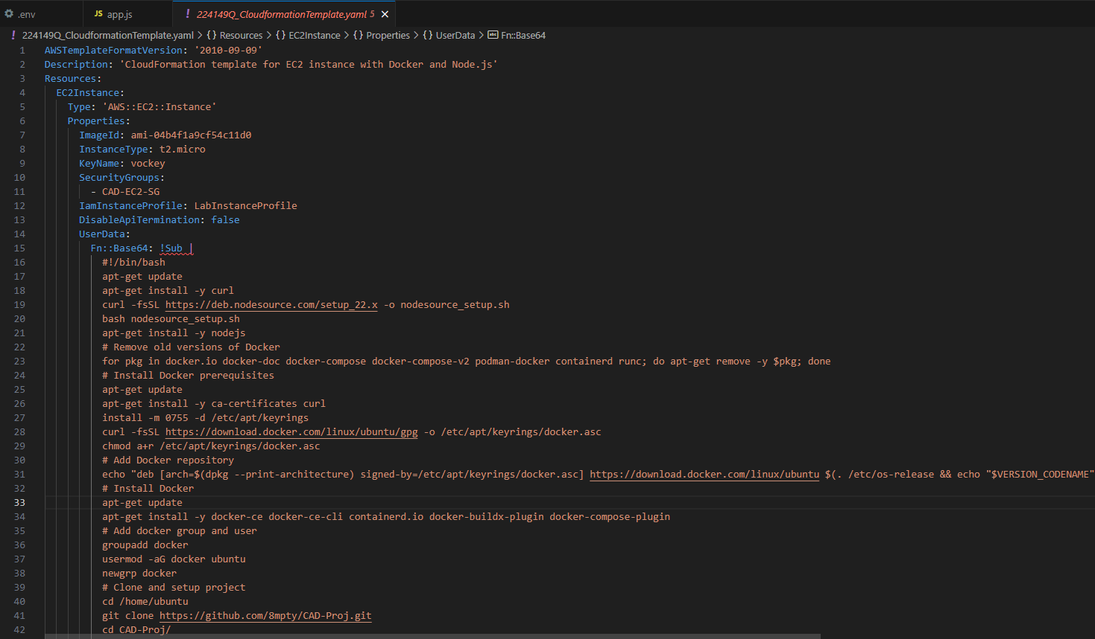
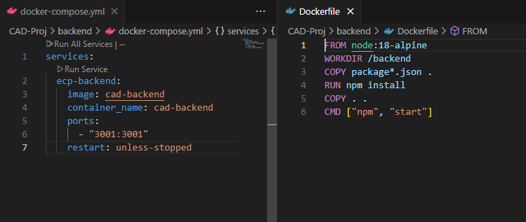

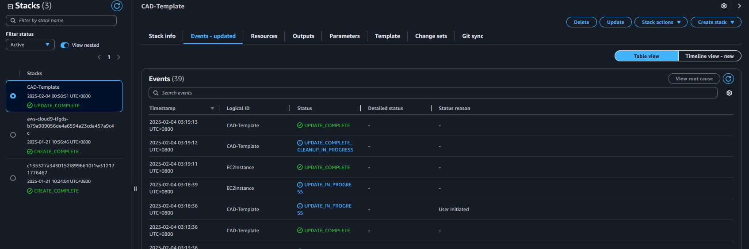

- Write a brief explanation on the future enhancement plan of your lost-and-found project.
For the future enhancement , I could definitely include the use of a Login form so that there could be management on the Admin side and the User side. The basic could then have it so that only the Admins are able to upload/delete/update the items while the users can only view or claim such items.
Official (Closed) and Non-Sensitive


IT3122 Cloud Application Development

Appendix – Rubrics

CATEGORY | A | B | C | D
Implementation (45%) | Completed all system with persistence storage integration and all managed cloud service that is aligned to the problem statement. The system is user friendly and caters to all groups of users fully. | Partial completion of system with persistence storage integration and some managed cloud service that is aligned to the problem statement. The system has some user-friendly features implemented. | Incomplete system with persistence storage integration and minimum or no managed cloud service that is aligned to the problem statement.  The system has basic user navigation components. | Incomplete system without persistence storage integration and no managed cloud service
Cloud Native Development (20%) | Demonstrate effective use of at least 5 managed cloud services. All the managed cloud services are fully integrated | Demonstrate effective use of 2 managed cloud service. The cloud services used are partially integrated | Able to identify and use basic cloud service suchs as compute, storage or database to implement the solution.  Some form of integration has been used. | Unable to use any cloud service to implement the system
Infrastructure as Code (15%) | Demonstrate effective use of infrastructure as code to create the cloud infrastructure automatically | Demonstrate partial use of infrastructure as code to create the cloud infrastruction partially | Able to create cloud infrastructure using the management console | Unable to completely create the cloud infrastructure
Explanation (20%) | Confident with good illustration and explanation to explain the work well. Logical and feasible proposals | Somewhat confident with decent illustration and explanation to somewhat explain the work done | Lack of confident with some illustration and explanation, but unable to explain the work well | No confidence, and little illustration and explanation, unable to describe the work done

<~The END~>

